

Practices for Secure Software Report

Table of Contents
Document Revision History 3
Client 3
Developer 4
1. Algorithm Cipher 4
2. Certificate Generation 4
3. Deploy Cipher 6
4. Secure Communications 6
5. Secondary Testing 7
6. Functional Testing 8
7. Summary 11
8. Industry Standard Best Practices 12

Document Revision History

Version | Date | Author | Comments
1.0 | 10/18/2026 | Ketlheen Silva

Client



Developer
Ketlheen Silva

Algorithm Cipher

For Artemis Financial, I recommend using the Advanced Encryption Standard (AES) with a 256-bit key to protect sensitive financial information. AES is a symmetric encryption algorithm, meaning that the same secret key is used to encrypt and decrypt data. It is widely used because it provides strong security while still being efficient for applications that handle large amounts of information (Manico & Detlefsen, 2014).
AES uses a 128-bit block size and supports key lengths of 128, 192, and 256 bits. I recommend AES-256 because its longer key provides additional protection against brute-force attacks (Computerphile, 2019; Oracle, n.d.). AES itself does not use a hash function. Instead, hashing can be used alongside encryption to verify data integrity. For this project, I implemented SHA-256, which produces a 256-bit hash value that can be used as a checksum to detect changes in data when compared with a trusted value (Computerphile, 2013; Oracle, n.d.).
Encryption also depends on secure key generation and management. Cryptographically secure random numbers are important because they help generate unpredictable keys and initialization values. Symmetric encryption uses one shared secret key, while asymmetric encryption uses a public and private key pair (Manico & Detlefsen, 2014). In HTTPS communications, asymmetric cryptography helps establish server identity and can support secure key exchange, while symmetric encryption protects the information exchanged during the connection.
Encryption has continued to improve as older algorithms have become less secure. During World War II, machines such as Enigma used mechanical rotors to encrypt messages. Later, computer-based algorithms such as the Data Encryption Standard (DES) became widely used. However, DES, which uses a 56-bit key, is no longer considered secure because advances in computing made brute-force attacks practical (Crash Course, 2017). AES was later selected as a stronger replacement and remains widely used today.
Although AES-256 is my recommendation for protecting Artemis Financial's stored financial information, this project focused on implementing SHA-256 hashing and HTTPS. These technologies serve different purposes. AES-256 provides confidentiality by encrypting information, while SHA-256 generates a checksum that can help verify data integrity. Using both encryption and hashing as part of a larger security strategy would provide different layers of protection for Artemis Financial's sensitive information (Manico & Detlefsen, 2014; Oracle, n.d.).

Certificate Generation
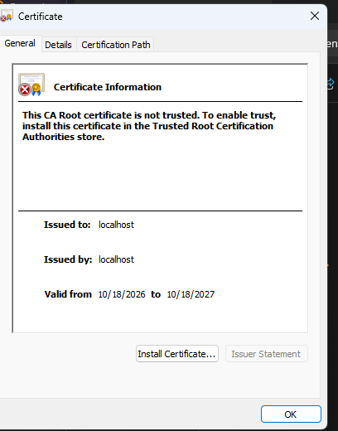
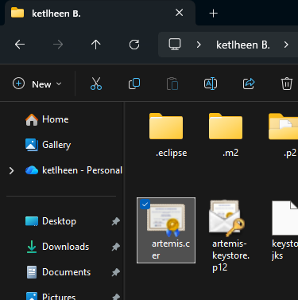

I used Java Keytool to generate a self-signed certificate with an RSA key pair and stored it in a PKCS12 keystore. I also exported the certificate as a CER file to document the certificate-generation process. Oracle (n.d.) explains that Java Keytool can be used to generate key pairs, manage certificates, and export certificates from a keystore.
The keystore was used to configure HTTPS for the Spring Boot application. This allowed the server to establish encrypted connections during local testing. Since the certificate was self-signed, the browser did not automatically trust its identity. For a production application, Artemis Financial should use a certificate issued by a trusted certificate authority, as recommended by OWASP Foundation (n.d.-c).

Deploy Cipher

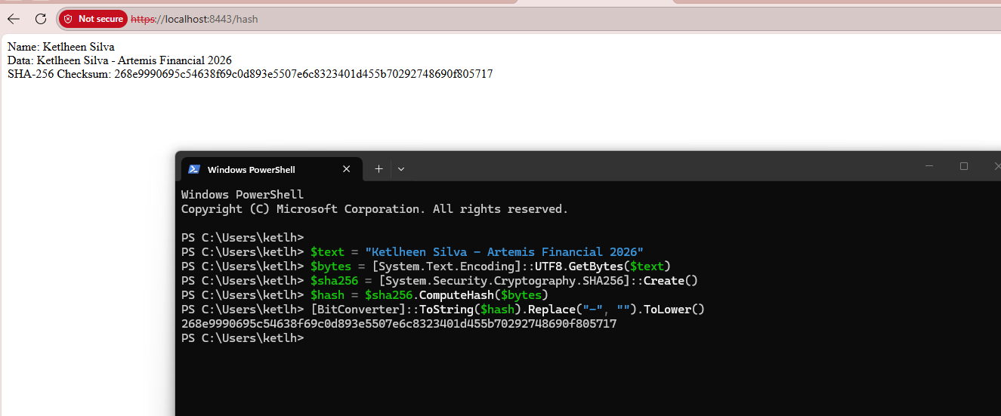

I refactored the application by creating a HashController.java class that uses the SHA-256 hashing algorithm to generate a checksum. I used Java's MessageDigest class to generate a 256-bit hash value from a unique data string.
To test the functionality, I ran the application in Eclipse and accessed the /hash endpoint through my web browser. The application successfully displayed my name, the original data string, and the generated SHA-256 checksum. This confirmed that the hashing functionality was working as expected.
For the checksum verification, I used the unique data string "Ketlheen Silva - Artemis Financial 2026." The SHA-256 algorithm processed the string and generated a 256-bit checksum displayed as a 64-character hexadecimal value. SHA-256 can help verify data integrity because changes to the original data would normally produce a different checksum (Oracle, n.d.).
To verify that my application generated the correct checksum, I used Windows PowerShell to independently calculate the SHA-256 hash of the same data string. I then compared the PowerShell result with the checksum displayed by my Java application. Both values matched exactly, confirming that the application generated the expected SHA-256 checksum. The screenshot above shows the matching results from the application and PowerShell.

Secure Communications
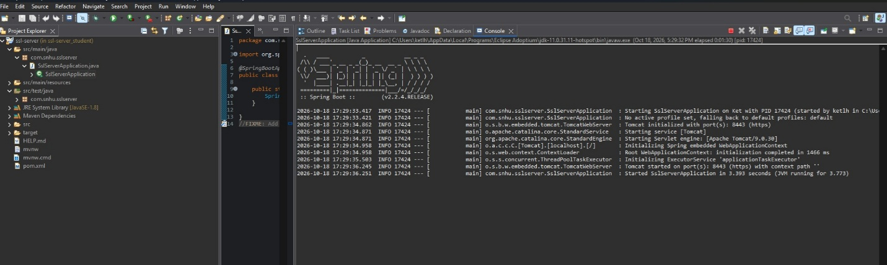

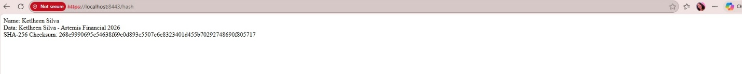

To improve the security of the application, I updated the application.properties file to enable HTTPS instead of using the default HTTP connection. I configured the server to run on port 8443 and use the Java keystore containing the self-signed certificate. Spring Boot (n.d.) documents the server configuration properties used to enable SSL/TLS and connect an application to a keystore.
After making these changes, I ran the SslServerApplication.java class in Eclipse. The console confirmed that the embedded Tomcat server started successfully on port 8443 using HTTPS.
I then opened https://localhost:8443/hash in my web browser and confirmed that the application returned the expected data and SHA-256 checksum. This demonstrated that the application could communicate using HTTPS. According to OWASP Foundation (n.d.-c), TLS helps protect information during transmission by providing confidentiality and integrity.
The browser displayed a "Not secure" warning because the certificate was self-signed and was not trusted by the browser. This warning did not automatically mean that the application was using HTTP. However, the self-signed certificate did not provide the same trusted identity verification as a certificate issued by a recognized certificate authority. OWASP Foundation (n.d.-c) recommends using certificates issued by trusted certificate authorities for public-facing applications. Although this configuration was appropriate for demonstrating HTTPS during local development and testing, Artemis Financial would need a trusted certificate for a production application.

Secondary Testing
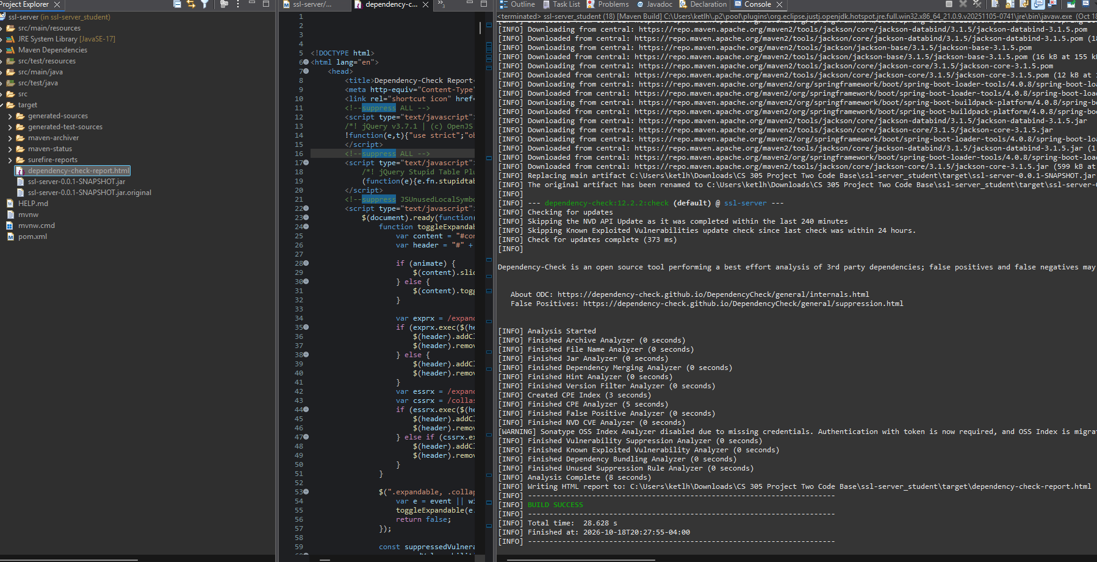
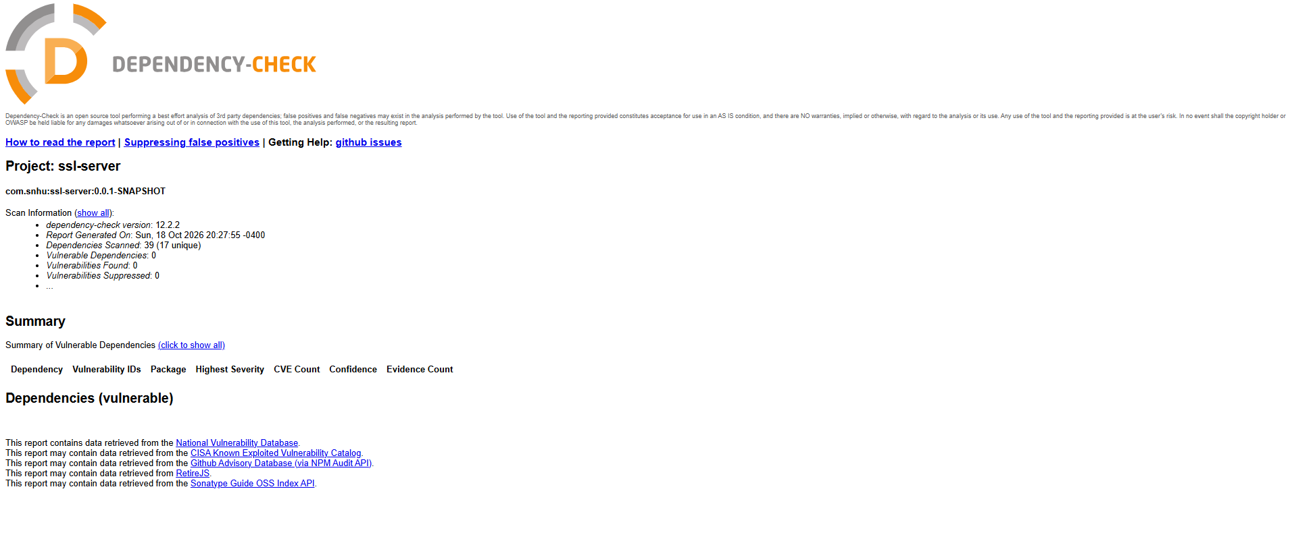
After refactoring the application, I performed secondary security testing using OWASP Dependency-Check version 12.2.2 through Maven in Eclipse. The purpose of this scan was to identify known vulnerabilities in the application's dependencies and verify that the security updates were successful. OWASP Foundation (n.d.) explains that Dependency-Check identifies publicly disclosed vulnerabilities in project dependencies. The initial scan identified 14 vulnerable dependencies and 254 vulnerability findings. To address these issues, I updated Spring Boot and several related dependencies, including Spring Framework, Apache Tomcat, Jackson, and Log4j. After each update, I ran the Maven build and reviewed the dependency-check report to determine whether additional vulnerabilities remained.
The final scan analyzed 39 dependencies, including 17 unique dependencies. The report identified zero vulnerable dependencies, zero vulnerability findings, and zero suppressed vulnerabilities. This demonstrates that the dependency updates successfully addressed the known vulnerabilities reported by the scanning tool.
The final results also show that the vulnerabilities were resolved through dependency updates rather than suppression. Although automated scans cannot guarantee that software is completely free of security risks, the results provide evidence that the application no longer contains known dependency vulnerabilities detected by OWASP Dependency-Check at the time of testing.
The final Maven configuration used Spring Boot 4.0.8, Spring Framework 7.0.9, Apache Tomcat 11.0.25, Jackson 3.1.4, and Log4j 2.25.5. These updates were made to address the vulnerable libraries identified in earlier scans. After updating the dependencies, I ran Maven's clean verify command and reviewed the new OWASP Dependency-Check report. The final results showed that the scanner did not identify any known dependency vulnerabilities at the time of testing. No vulnerabilities were suppressed to obtain this result.

Functional Testing
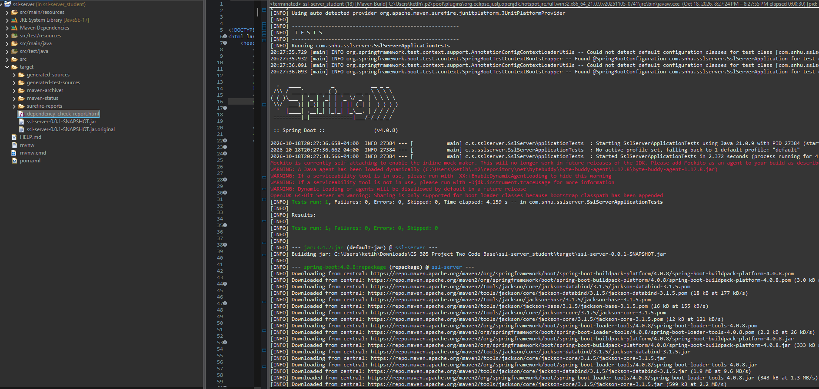
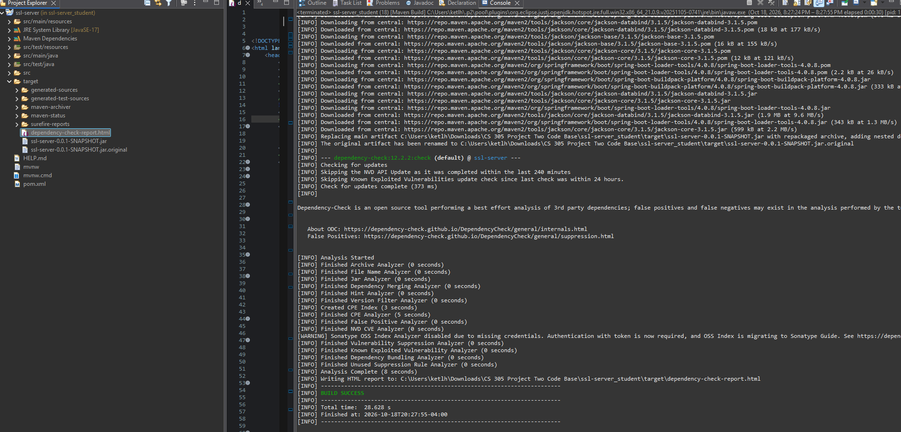

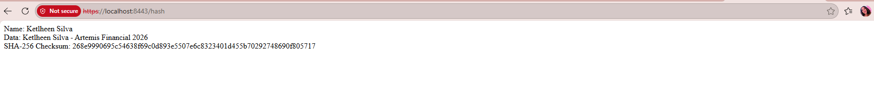
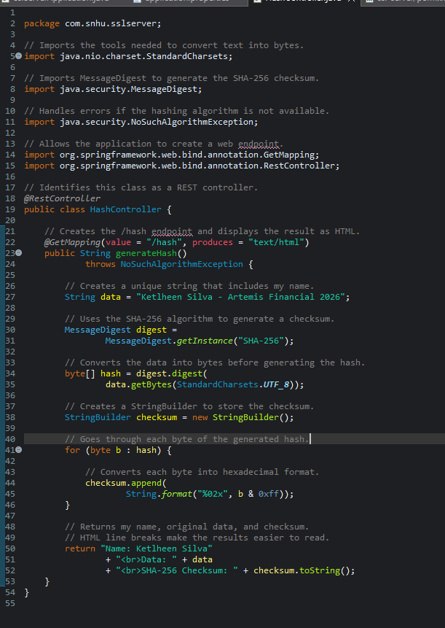

After completing the security updates, I performed functional testing and manually reviewed the application to identify possible syntactical, logical, and security vulnerabilities. As part of the project, I created HashController.java to implement the SHA-256 checksum functionality, configured the application.properties file to enable HTTPS, and made corrections to SslServerApplication.java. I also updated pom.xml to address vulnerabilities in the application's dependencies. These four files were reviewed because they contain the application's hashing functionality, startup configuration, HTTPS settings, and dependency management.
For syntactical issues, I reviewed the Java classes and Maven configuration to check for errors that could prevent the application from compiling or running. I made sure that SslServerApplication.java contained the correct main method for starting the Spring Boot application and that the new HashController.java class was properly configured to handle requests to the /hash endpoint. I used Maven's clean verify command to rebuild the application and run the configured tests. The build completed successfully, and I was able to start the application in Eclipse. No syntax errors preventing compilation or execution were identified during this testing.
For logical issues, I reviewed the checksum generation process that I implemented in HashController.java. I needed to make sure that it correctly processed the data and generated the expected output. The controller uses Java's MessageDigest class with SHA-256 and converts the data string into bytes using UTF-8 encoding. The resulting hash is then converted into a hexadecimal value and displayed with the original data. I tested this functionality by opening https://localhost:8443/hash in my browser. The application successfully displayed my name, the data string "Ketlheen Silva - Artemis Financial 2026," and the generated SHA-256 checksum. This confirmed that the hashing functionality operated as expected.
For security issues, I reviewed the application's HTTPS configuration and dependency management. The original application.properties file did not contain the completed HTTPS configuration, so I added the necessary settings to enable HTTPS on port 8443 and connect the application to the self-signed certificate stored in a PKCS12 keystore. I also configured the keystore password to be referenced through an environment variable rather than writing it directly in the configuration file. This helps avoid exposing the password in the application's source configuration.
I also reviewed pom.xml to verify the updated dependency versions and the OWASP Dependency-Check configuration. The final project used Spring Boot 4.0.8, Spring Framework 7.0.9, Apache Tomcat 11.0.25, Jackson 3.1.4, and Log4j 2.25.5. The final Dependency-Check scan analyzed 39 dependencies and reported zero vulnerable dependencies, zero vulnerability findings, and zero suppressed vulnerabilities.
The manual review also identified areas that would require additional consideration in a production environment. The self-signed certificate would need to be replaced with a certificate issued by a trusted certificate authority, and the keystore credentials would need to remain protected.
Overall, the manual code review and functional testing did not show any syntax or checksum logic errors that prevented the application from working correctly. The Maven build was successful, the HTTPS endpoint worked as expected, and the final dependency scan reported no known vulnerabilities. These results showed that the SHA-256 hashing, HTTPS configuration, and dependency updates were working properly together. Although the application would need additional security measures before being used in a production environment, the changes made during this project improved its security without affecting its functionality.

Summary

Throughout this project, I made changes to the Artemis Financial application to improve its security and make sure it continued to work correctly. The main improvements included creating the SHA-256 hashing functionality, generating and exporting a self-signed certificate using Java Keytool, configuring HTTPS, correcting the application startup code, and updating vulnerable dependencies identified through security testing.
Following the vulnerability assessment process, I focused on several areas of security, including cryptography, client/server communication, APIs, code quality, and dependency management. Cryptography was addressed by implementing SHA-256 hashing through Java's MessageDigest class to generate a checksum for the application's data. Client/server communication was improved by configuring HTTPS on port 8443 using a PKCS12 keystore and a self-signed certificate. I also created and tested the /hash endpoint to confirm that the application could successfully display the original data and generated checksum.
To improve code quality and security, I created HashController.java, configured the previously empty application.properties file, and made corrections to SslServerApplication.java. I also reviewed these files and pom.xml for possible syntactical, logical, and security issues. In addition, I updated Spring Boot and several related dependencies to address vulnerabilities identified during the initial OWASP Dependency-Check scan. The final configuration used Spring Boot 4.0.8, Spring Framework 7.0.9, Apache Tomcat 11.0.25, Jackson 3.1.4, and Log4j 2.25.5.
After completing the updates, I performed secondary testing using OWASP Dependency-Check and functional testing through Eclipse and the web browser. The final security scan analyzed 39 dependencies and reported zero vulnerable dependencies, zero vulnerability findings, and zero suppressed vulnerabilities. Functional testing also confirmed that the application worked correctly through HTTPS and successfully generated the SHA-256 checksum.
Overall, this project showed me the importance of using different security measures instead of relying on just one. SHA-256 hashing helps check data integrity, HTTPS helps protect information during transmission, and keeping dependencies updated reduces the risks associated with vulnerable software libraries. Together, these changes helped make the Artemis Financial application more secure while allowing it to continue working as expected.

Industry Standard Best Practices

Several industry-standard best practices were applied throughout this project to improve the security of the Artemis Financial application. These practices included using established cryptographic algorithms, securing client/server communications, protecting sensitive configuration information, maintaining updated dependencies, and performing security testing after making changes to the application.
One important practice was using established Java security libraries instead of creating a custom hashing algorithm. I implemented SHA-256 through Java's MessageDigest class, which provides a standardized method for generating cryptographic checksums. SHA-256 supports data integrity because a generated checksum can be compared with a trusted checksum to identify possible changes in information. In this project, the application generated and displayed the checksum. Using established security libraries also helps reduce the risks associated with developing custom cryptographic solutions (Manico & Detlefsen, 2014; Oracle, n.d.).
Another important practice was securing communication through HTTPS. I generated a self-signed certificate using Java Keytool, exported it as artemis.cer, and configured the application to use a PKCS12 keystore on port 8443. The application.properties file also references the keystore password through an environment variable instead of storing the password directly in the configuration file. This is important because sensitive credentials should not be exposed in source code. Although the self-signed certificate was appropriate for local testing, a production application should use a certificate issued by a trusted certificate authority to provide stronger server identity verification (OWASP Foundation, n.d.).
Dependency management was also an important part of the security improvements. I used OWASP Dependency-Check to identify libraries with known vulnerabilities and updated Spring Boot, Spring Framework, Apache Tomcat, Jackson, and Log4j. After each major update, I rebuilt the application and reviewed the new scan results. The final report identified zero vulnerable dependencies and zero vulnerability findings without suppressing any results. This showed the importance of keeping software components updated and regularly scanning applications for known security risks.
In addition, I manually reviewed the application's Java code and configuration files to check for syntactical, logical, and security issues. This included reviewing the hashing functionality in HashController.java, the startup code in SslServerApplication.java, the HTTPS settings in application.properties, and the dependency configuration in pom.xml. I also performed functional testing to make sure the application continued to work correctly after the changes.
These security practices are particularly important for a financial organization such as Artemis Financial because protecting sensitive information and maintaining customer trust are essential. The Federal Trade Commission (2024) emphasizes the importance of implementing appropriate safeguards to protect customer information for financial institutions covered by its Safeguards Rule. Although this project was developed for local testing, the practices demonstrated could support a more secure production application.
Overall, this project showed that secure software development requires continuous attention to cryptography, communication security, dependency management, and testing. Applying these practices can help Artemis Financial reduce security risks, protect information, and maintain the reliability of its applications.

References
Computerphile. (2013, November 8). Hashing algorithms and security [Video]. YouTube.
(1753) Hashing Algorithms and Security - Computerphile - YouTube
Computerphile. (2019, November 22). AES explained (Advanced Encryption Standard) [Video].
YouTube. (1753) AES Explained (Advanced Encryption Standard) - Computerphile - YouTube
Crash Course. (2017, October 25). Cryptography: Crash Course Computer Science #33 [Video].
YouTube. https://www.youtube.com/watch?v=jhXCTbFnK8o
Federal Trade Commission. (2024). FTC Safeguards Rule: What your business needs to know.
https://www.ftc.gov/business-guidance/resources/ftc-safeguards-rule-what-your-business-needs-know
Manico, J., & Detlefsen, A. (2014). Iron-clad Java: Building secure web applications. McGraw-
Hill Education.
Oracle. (n.d.). Java Security Standard Algorithm Names. Java Platform, Standard Edition 9.
https://docs.oracle.com/en/java/javase/11/docs/specs/security/standard-names.html
Oracle. (n.d.). The keytool command.
https://docs.oracle.com/en/java/javase/17/docs/specs/man/keytool.html
OWASP Foundation. (n.d.). Dependency-Check.
https://owasp.org/www-project-dependency-check/
OWASP Foundation. (n.d.). Transport layer security cheat sheet. OWASP Cheat Sheet Series.
https://cheatsheetseries.owasp.org/cheatsheets/Transport_Layer_Security_Cheat_Sheet.html
Spring Boot. (n.d.). Common application properties. Spring.
https://docs.spring.io/spring-boot/4.0/appendix/application-properties/index.html

